
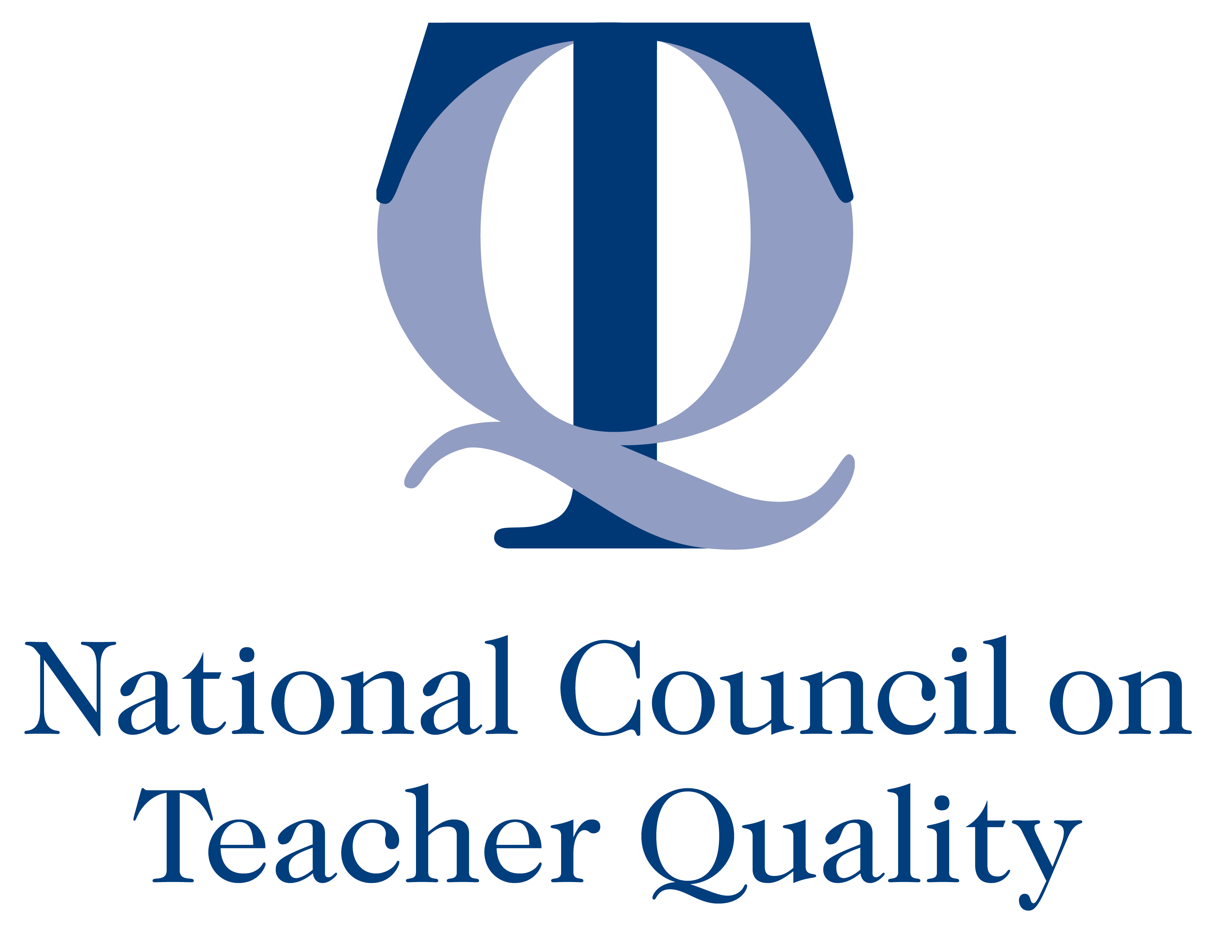

MEDIA CONTACTS:
Fabiola Fleuranvil, Urban League of Greater Miami
Fabiola@BlueprintCreativeGroup.com or (305) 741-0378

Lisa Cohen, NCTQ
lisa@lisacohen.org or (310) 395-2544

National Council on Teacher Quality Releases Report on Teacher Equity in
Miami-Dade County Public Schools

Study finds inequality in teacher performance,
with disproportionate impact on the most vulnerable students

August 18, 2014 -- The National Council on Teacher Quality (NCTQ) released a report examining the distribution of teachers in Miami-Dade County Public Schools. The in-depth study, Unequal Access, Unequal Results: Equitable Teacher Distribution in Miami-Dade County Public Schools, was commissioned by the Urban League of Greater Miami and will be released in a public community meeting on Wednesday, August 20th from 6PM – 8PM at Freedom Hall of the Urban League offices located at 8500 NW 25th Ave, Miami.

The report provides substantiating evidence that there is widespread inequality in Miami-Dade when it comes to the performance of the teacher workforce, and this inequality disproportionately impacts the county’s most vulnerable students living in voting Districts 1 and 2, which have high concentrations of African-American and low-income students. Students in district 1 and 2 are far more likely to have the least experienced and least effective teachers and significantly more teacher turnover, thus creating unstable learning environments.

“The consequences of unequal distribution of effective teachers in Miami-Dade are harsh and shameful,” said T. Willard Fair, President of the Urban League of Greater Miami. “The disparity in Miami-Dade is emblematic of a nationwide failure to provide all students with experienced and effective teachers. We cannot allow our schools to deny educational opportunities to our most vulnerable students.”

The report provides detailed recommendations about methods to improve students’ access to effective teachers:
- Create incentives to encourage high-performing teachers to take and stay in positions in high-needs schools.
- Provide more support to new teachers to improve teacher effectiveness.
- Recruit and hire teachers from training programs that prepare them for the classroom.

“While Miami-Dade County Public Schools have made strides in many areas, there are still students who are not getting the support they need to succeed, said Nancy Waymack, Managing Director of District Policy at NCTQ. “The district needs to redouble efforts to ensure all of its students have access to effective teachers.”

Media is invited to attend the community meeting hosted where the report will be shared with parents and interested members of the community. To confirm attendance, please contact Fabiola@BlueprintCreativeGroup.com.

The full report will be released online on August 20. To request an advanced copy or to speak with a representative from NCTQ about the report findings, contact Lisa Cohen at lisa@lisacohen.org.

About the National Council on Teacher Quality
The National Council on Teacher Quality advocates for reforms in a broad range of teacher policies at the federal, state, and local levels in order to increase the number of effective teachers. In particular we recognize the absence of much of the evidence necessary to make a compelling case for change and seek to fill that void with a research agenda that has direct and practical implications for policy. We are committed to lending transparency and increasing public awareness about the four sets of institutions that have the greatest impact on teacher quality: states, teacher preparation programs, school districts and teachers unions. For more information, visit: www.nctq.org.

About the Urban League of Greater Miami

The mission of the Urban League of Greater Miami is to enable black children to reach their fullest potential and their parents to exercise their rights and assume their responsibilities as adults. Our vision: Every child born in Liberty City shall grow up to be healthy, happy and successful. We strive towards our mission and vision daily through a focus on education, women and children, and community empowerment.

